Aws console

**Step 1 :To create vpc**

In your vpc

Selecte create vpc

[]Select vpc only

[] in ipv4 CIDR **better** to use 10.0.0.0/16

ex:172.15.0.0/16 (here we use class B network means 178.16.0.0. to 178.31.0.0 don’t use 172.17 bcz it is docker default ip )

[]create vpc

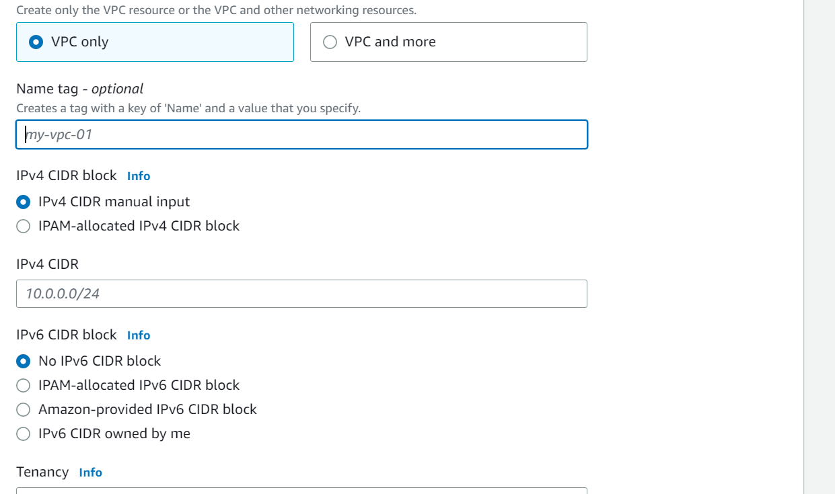

[]right click on created vpc

[]select edit vpc

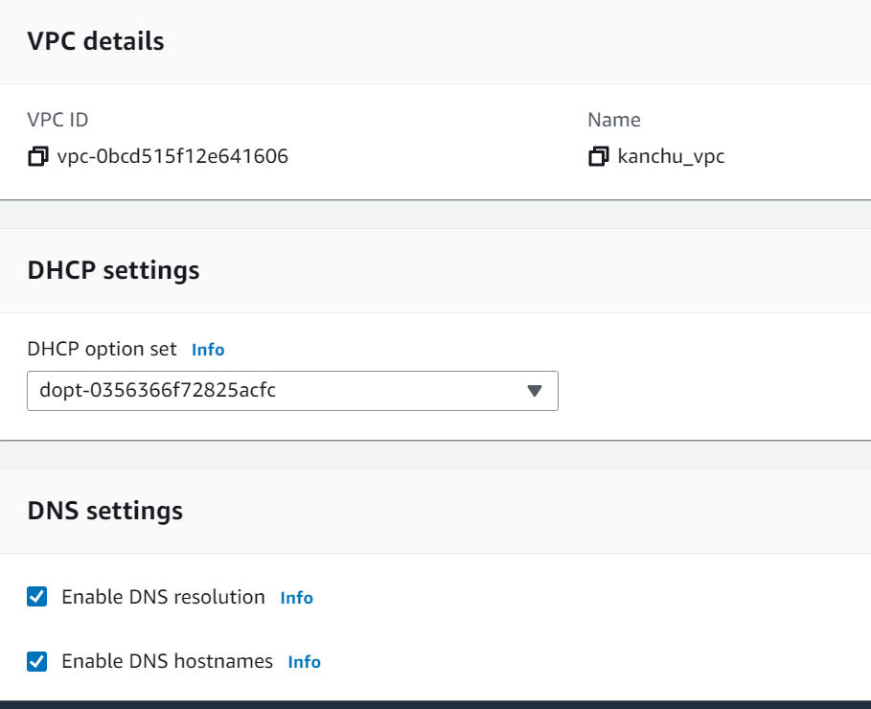

[] Enable DNS hostnames

[] save

**Step 2: to create subnet:**

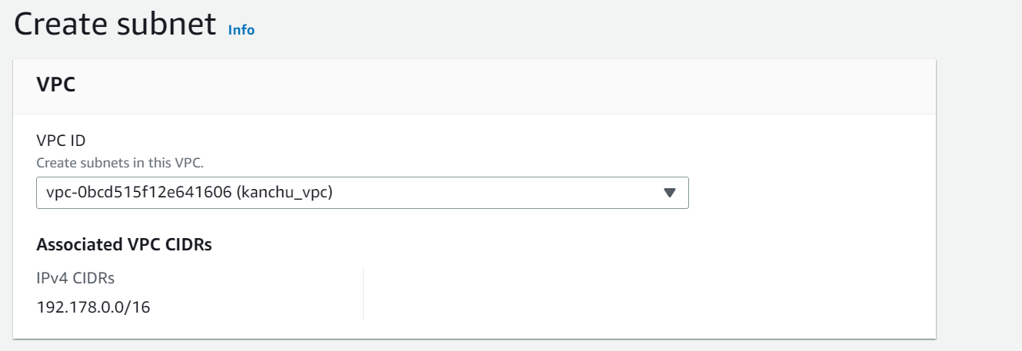

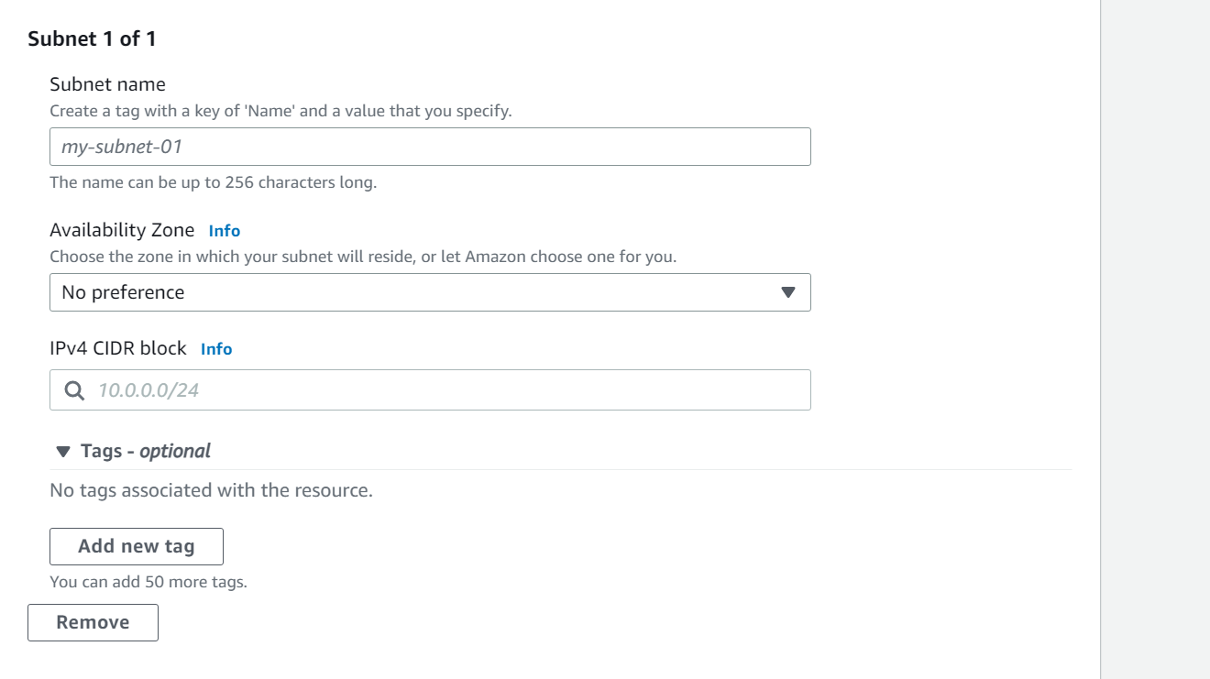

[] In vpc ID select which vpc we want

[] sunnet name give whatever

[] in availability zone choose zone

[] ipv4 CIDR block ex:10.0.2.0/24 (3rd bit we need change , here we use in vpc what we mention for ip)

[] create subnet

[] enable auto-assign ipv4

[] save

**Step 3:To create internet gateway create:**

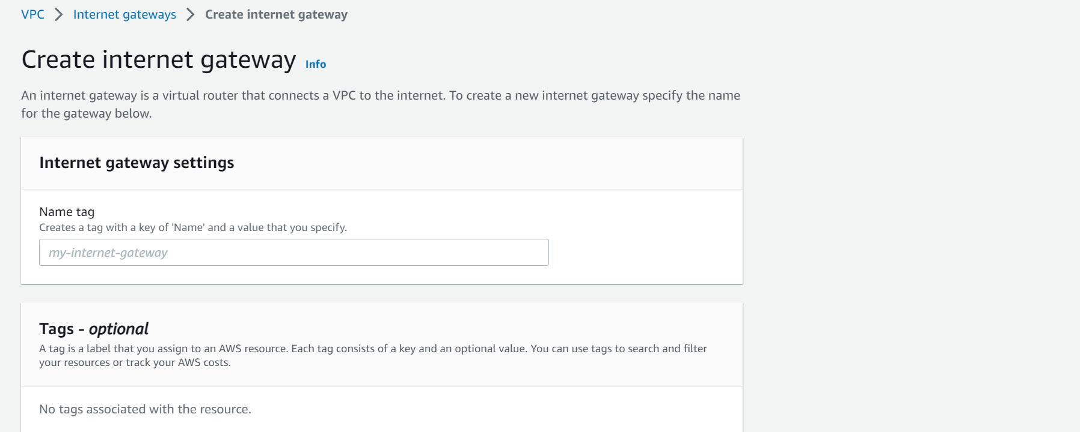

[] In name tag we can give whatever we want ex: kanchana_gat

Next, we want to attach this internet gateway for VPC. You can select the internet gateway and click Attach to VPC.

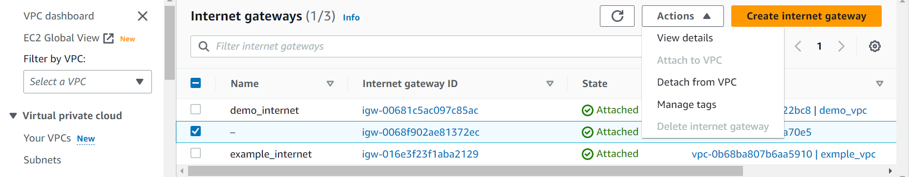

Next, select the previously created VPC and click attach internet gateway button.

**Step 4:to create Route table**

[] when we create vpc route table also create (check in route table drag table there we find vpc column there check VPC id )

[] select route table what we created right click select edit route and add route 0.0.0.0/0 and select the previously created Internet Gateway. next hit the save changes button.

[] save change

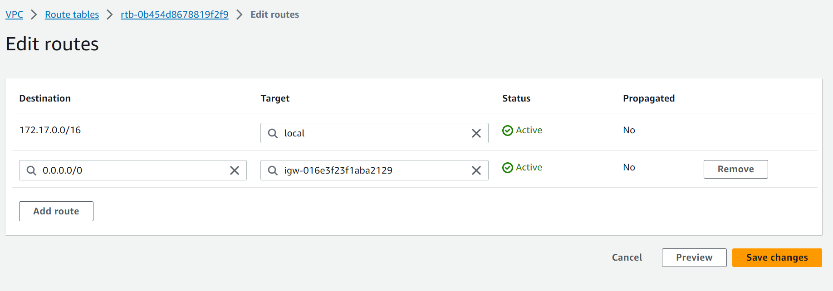

[] in down select

[] subnet associations

## [] in **Explicit subnet associations** (1) select Edit subnet associations

[] add the subnet which we created/ which we want

[] save

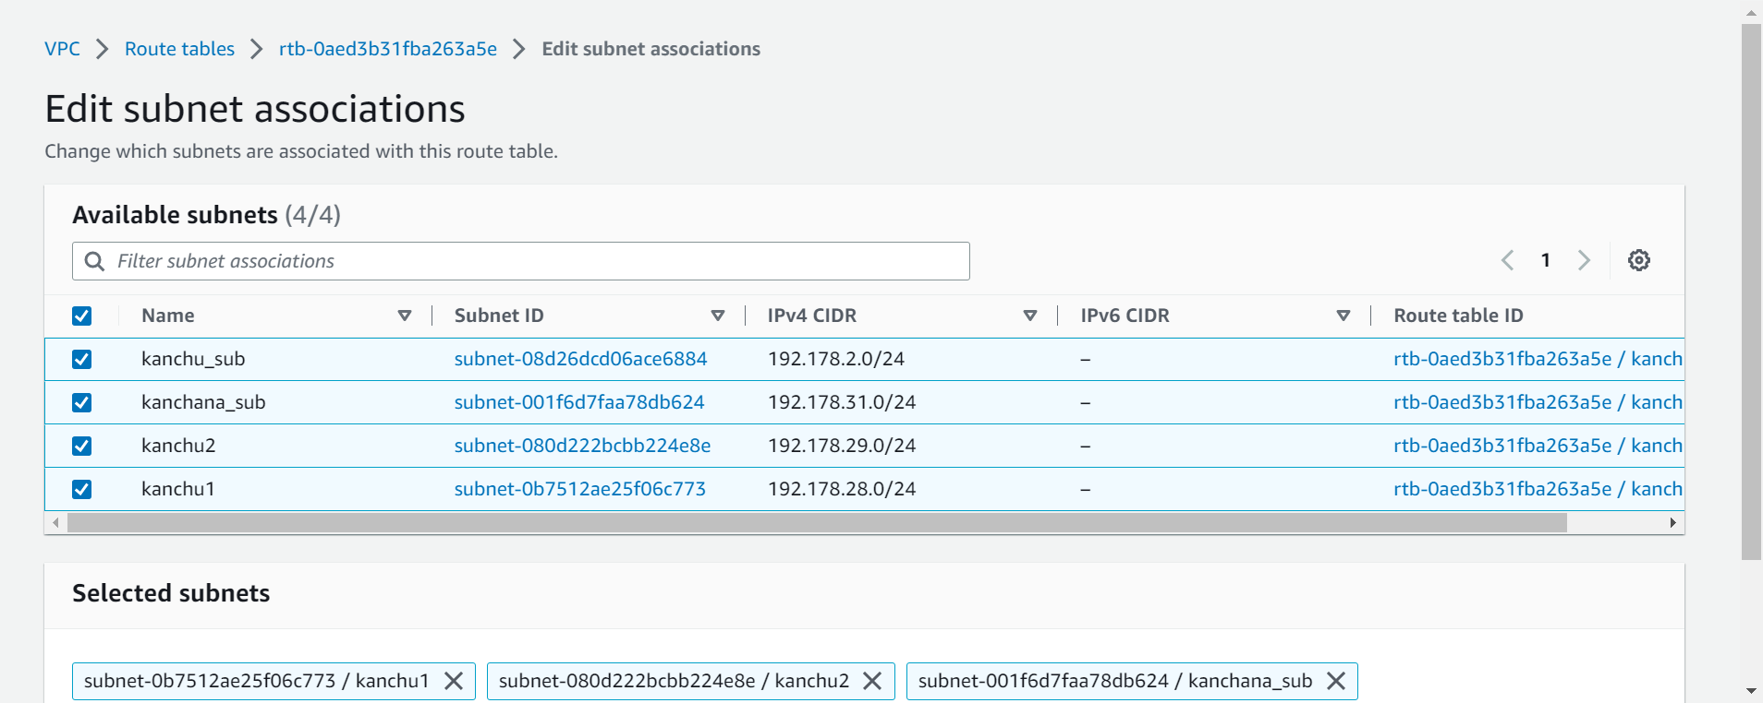

**In subnet:**

Now we go to public subnet and click subnet settings and enable "Enable auto-assign public IPv4 address" and click save.

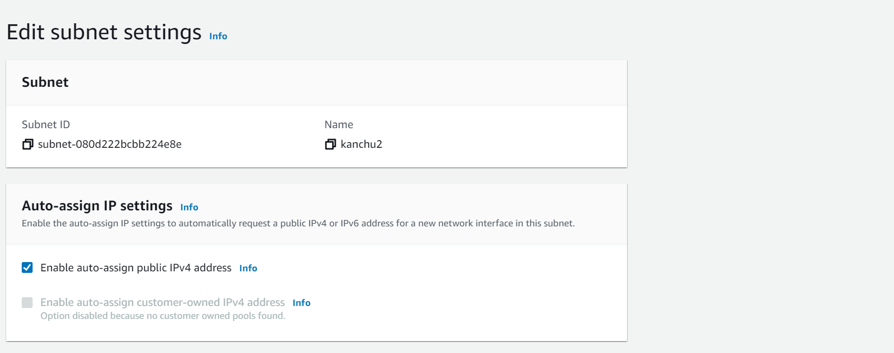

**To launch Instance:**

[] select EC2 global view

[] in search bar search EC2

[] Selecte EC2

[] In lift side select instances

[] selecte launch instance

[] in name and tags give whatever we want

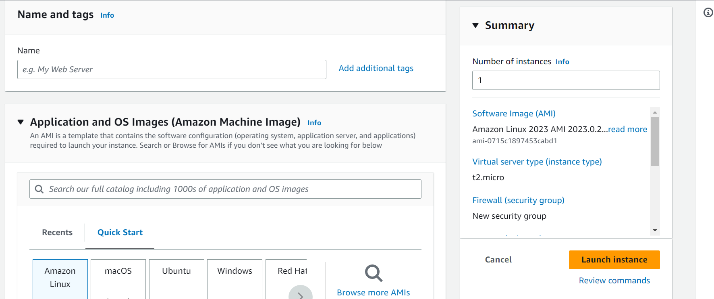

[] in quick start select which we want

[] in AMI

[] select free tier eligible

[] instance type also selects free tier eligible

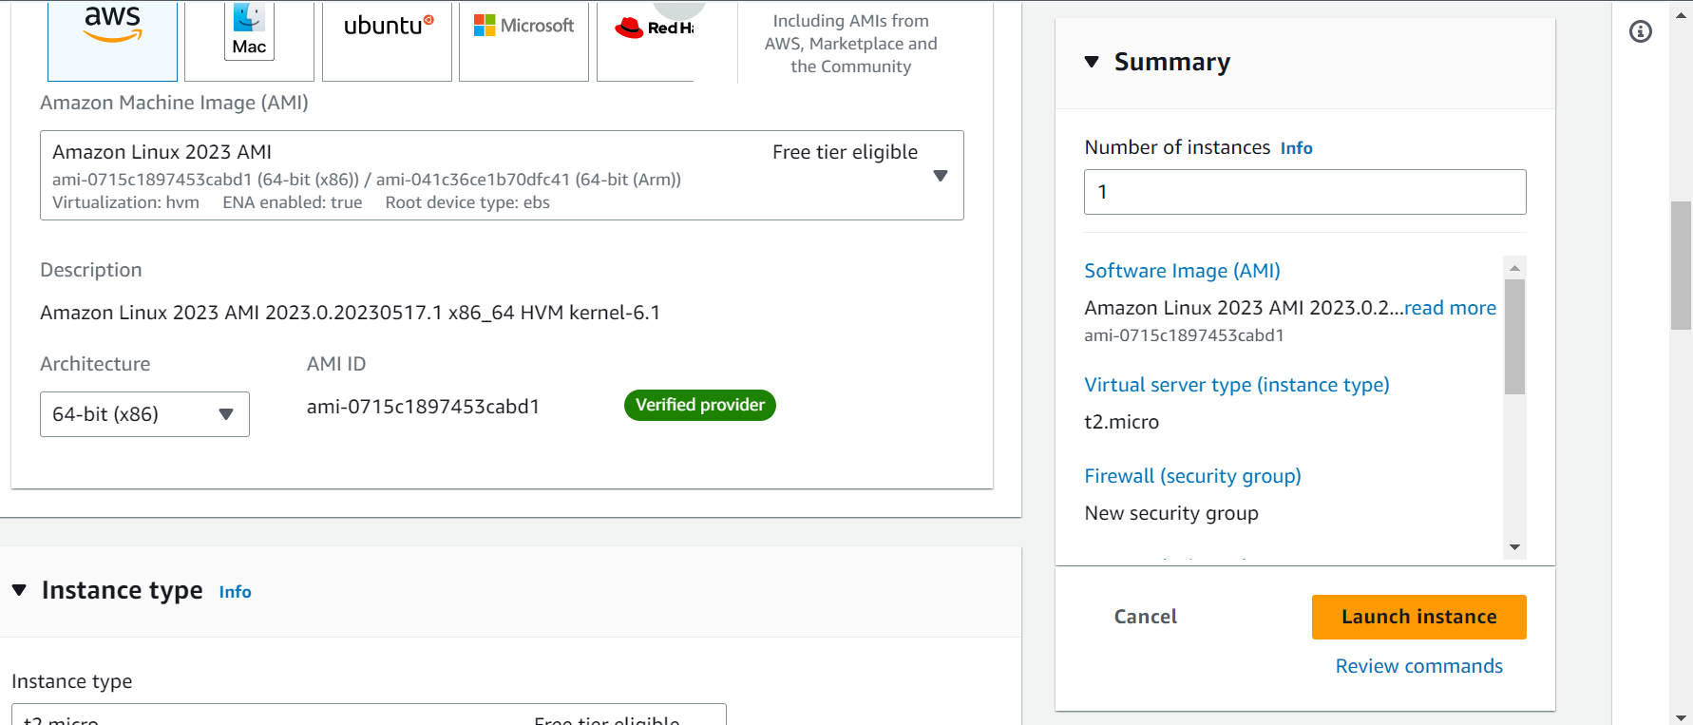

[] In key pair

[] first we need to create key pair

[] select create key pair select RSA and .pem

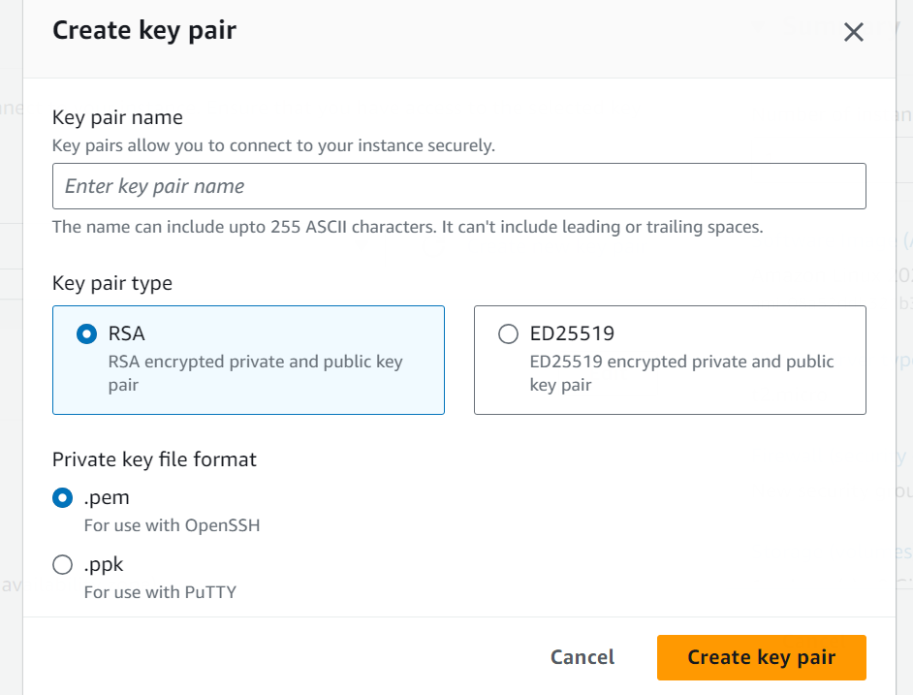

[] after creating key pair in puttygen select load and choose .pem what we created

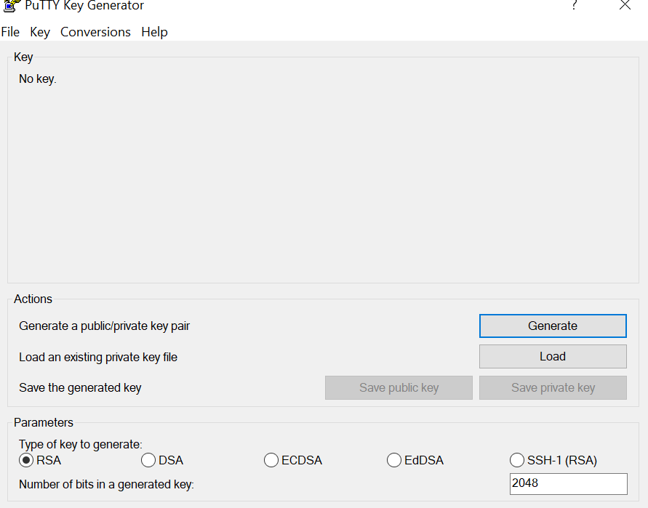

[] choose all file in fill name

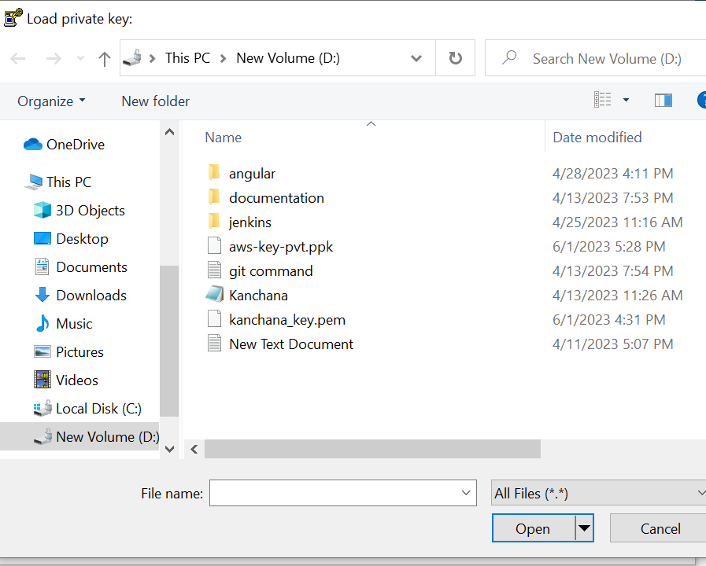

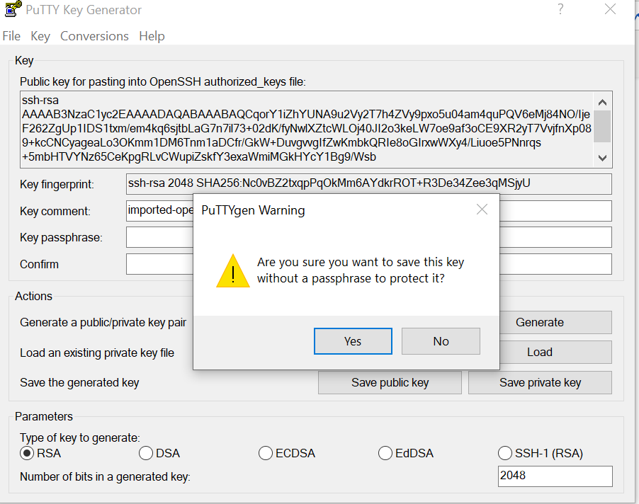

[] select save private key

[] yes

[] save the file

[] In network setting

[] edit

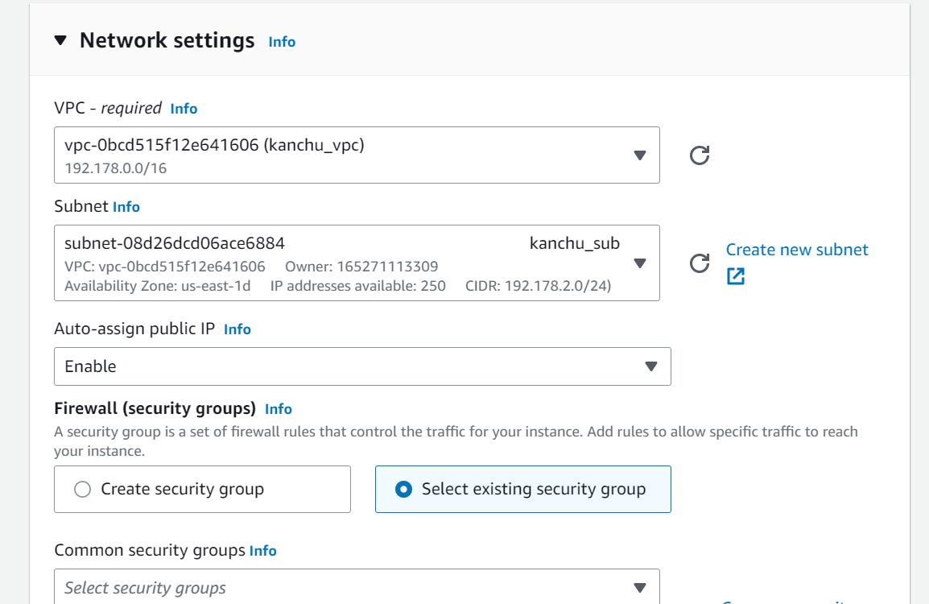

[] In vpc required select which we want

[] in firewall select existing security grp if we already created/

[] in common security groups select which we created

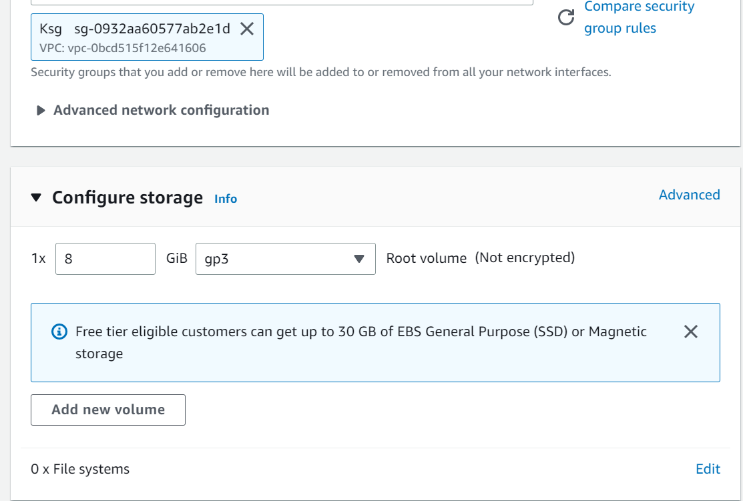

[] in firewall in first time select create security group

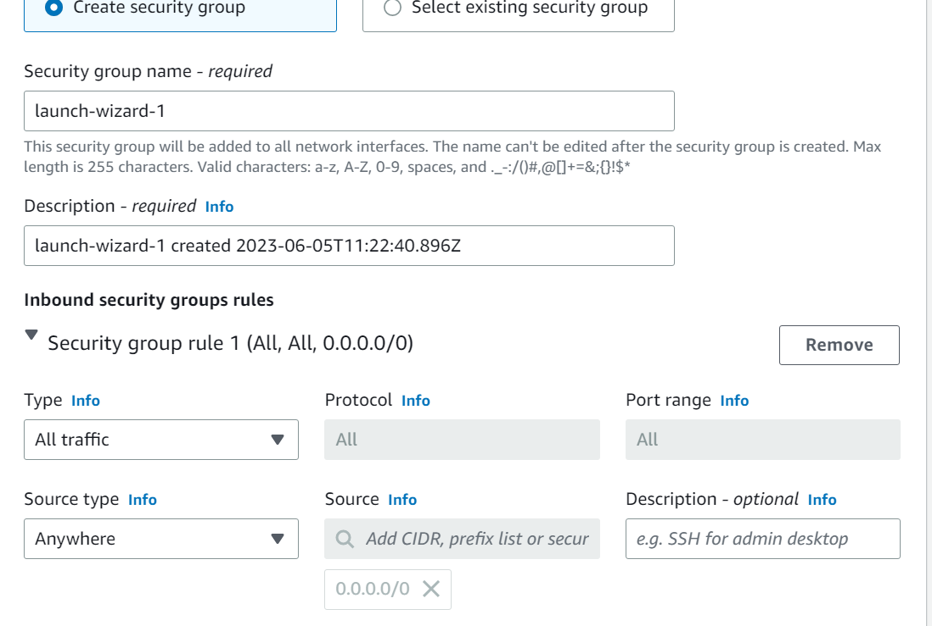

Puttyexe:

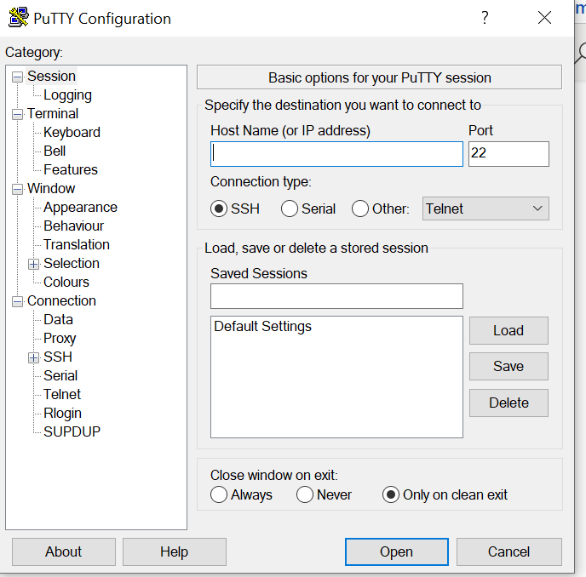

[] In host name if we use ubuntu (ubuntu@publicip) if use aws (ec2-user@publicip)

[] SSH

[] Auth

[] credentials

[] in browser select file what we create file in puttygen